Server Document

<http://www.rabbitmq.com/admin-guide.html>

部署与配置RabbitMQ Server。

而对于RabbitMQ Client，指的是编写Java代码利用RabbitMQ 这个工具。

对于性能优化等需要懂RabbitMQ Server的一些配置。

RabbitMQ ships in a state where it can be used straight away in simple cases such as development and QA environments - just start the server and it's ready to go. **If you have more complex needs you may need to adjust your server configuration.**

This guide provides a table of contents of **server operator documentation**.

# Configuring your RabbitMQ Server

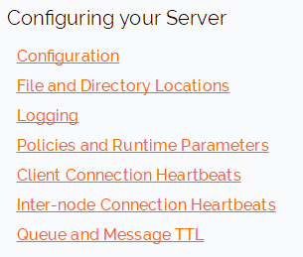

# CLI tools

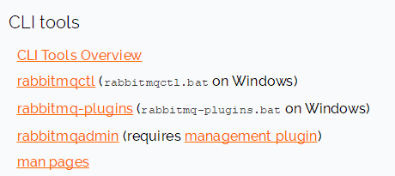

# Authentication and Authorization

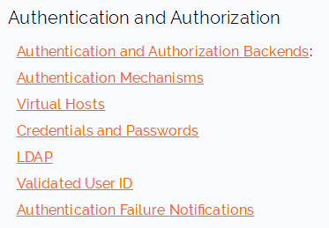

# Networking and TLS

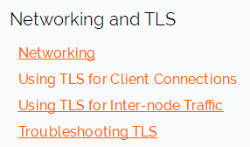

# Monitoring, Audit, Application Troubleshooting

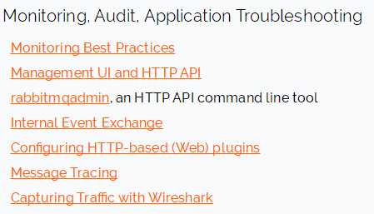

# Distributed RabbitMQ

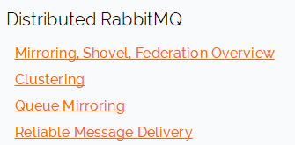

# Guidelines

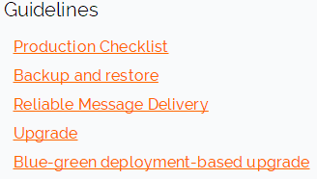

# Message Store and Resource Management

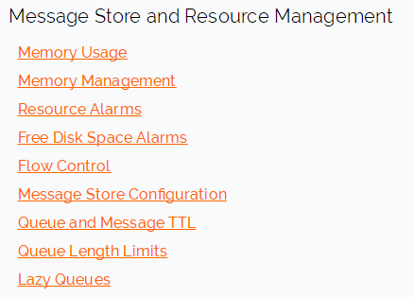

# STOMP, MQTT, WebSockets

